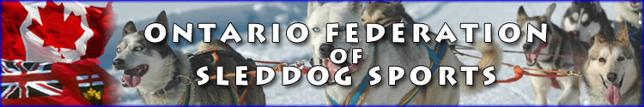

Killara Station OFSS Skijoring Trails
Seasons Passes Dec 1st 2017/18.
5205 Gelert Rd
Minden ON Canada

$100 + $30 for OFSS membership good for all OFSS events/clinics and lessons till Spring. Arrange OFSS membership and pass payment with Karen at 705-457-7902.

Killara Station OFSS Skijoring Day Passes

$10 + $30 for OFSS membership good for all OFSS event till Spring. Use Honor Box and arrange OFSS membership payment with Karen at 705-457-7902.

You may come at any time except between 9:00am and 11:00am when the owner will be running her dogs. Remember to keep your dog on the lead on the property.

