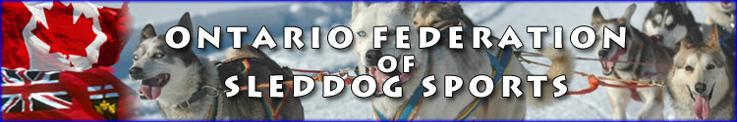
OFSS Winter Newsletter 2017/18

Hi Everyone!

Just wanted to give you a winter update. Lots of things going on for OFSS members. We are happy to announce we have a trail available throughout the winter months for OFSS skijorers and sledders. The trail is located in Haliburton area. See the information at the bottom of this email.

Elmer’s Camp will hopefully be going Dec 28 to 31. Keep an eye on the OFSS website for updates.

Every Monday throughout the winter, skijor lessons and Tips and Tricks sessions are available to OFSS members. We can also make special arrangements if you can’t make Mondays. You can sign up with Yours Outdoors at http://yoursoutdoors.ca/packages/skijoring-adventure-your-dog. The last two weekends of January (20, 21, 27, 28th) will likely have lessons blocks available through Yours Outdoors, and possibly a fun race on the Sunday at the same location as the skijoring/ sledding trail. Updates will be on the OFSS website and on the Yours Outdoors website. You can always text, call or OFSS FB messenger me if you are interested in a lesson. If you are interested in the fun race idea mentioned above send me a text or write on the OFSS FB messenger that you are interested.

Have a fantastic holiday season, and hopefully we will see you this winter.

Cheers!
OFSS President, Karen Koehler

Killara Station OFSS Skijoring Trails
Seasons Passes Dec 1st 2017/18.

$100 + $30 for OFSS membership good for all OFSS events/clinics and lessons till Spring. Arrange OFSS membership and pass payment with Karen at 705-457-7902.

Killara Station OFSS Skijoring Day Passes

$10 + $30 for OFSS membership good for all OFSS event till Spring. Use Honor Box and arrange OFSS membership payment with Karen at 705-457-7902.

You may come at any time except between 9:00am and 11:00am when the owner will be running her dogs. Remember to keep your dog on the lead on the property.

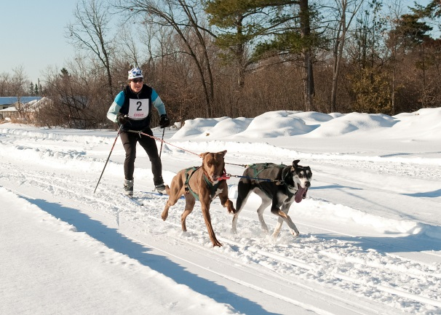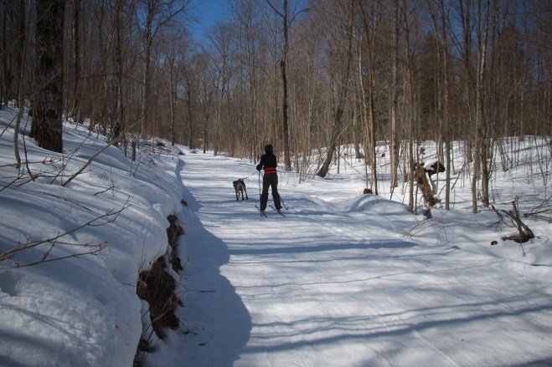

New for OFSS members. Skijor Lessons Available in the Haliburton Area. For more information see
http://yoursoutdoors.ca/packages/skijoring-adventure-your-dog

