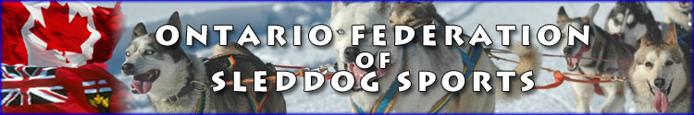

OFSS Skijor lessons

Location:
Killara Station, 5205 Gelert Rd. Minden.

Instructor:
Karen Koehler (top North American in 2 dog skijor at 2017 IFSS World Championship)

Contact: ofss1@yahoo.ca if you are interested in lessons
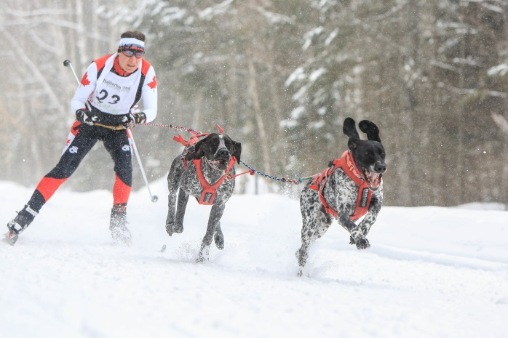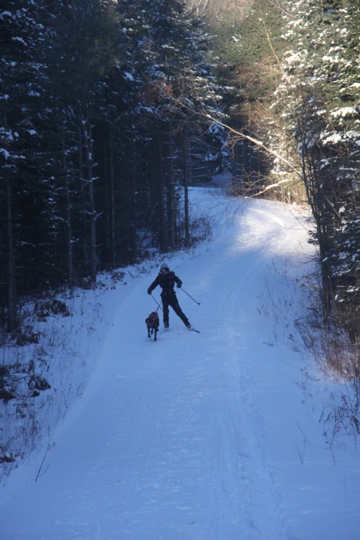
Photo by Marie Parent Photo by Karen Koehler

OFSS Skijoring Trails
Seasons Passes Dec 1st 2017/18.

Gelert Rd. Minden

$100 + $30 for OFSS membership good for all OFSS events/clinics and lessons till Spring. Arrange OFSS membership and pass with using ofss1@yahoo.ca.
OFSS Skijoring Day Passes

$10 + $30 for OFSS membership good for all OFSS event till Spring. Use Honor Box and arrange OFSS membership payment using ofss1@yahoo.ca
You may come at any time except between 9:00am and 11:00am when the owner will be running her dogs. Remember to keep your dog on the lead on the property.

